**ARYAMAN MISHRA**

**19BCE1027**

Write an 8086 ASM code to perform the following operations

a) To reveres the given string

assume cs:code,ds:data,es:data

data segment

str1 db "sakthivel$"

strlen1 dw $-str1

strrev db 20 dup(?)

data ends

code segment

start:

mov ax,data

mov ds,ax

mov es,ax

mov cx,strlen1

add cx,-2

lea si,str1

lea di,strrev

add si, strlen1

add si,-2

l1:

mov al,[si]

mov [di],al

dec si

inc di

loop l1

mov al,[si]

mov [di],al

inc di

mov dl,'$'

mov [di],dl

print:

mov ah,09h

lea dx, strrev

int 21h

exit:

mov ax,4c00h

int 21h

hlt

code ends

end start

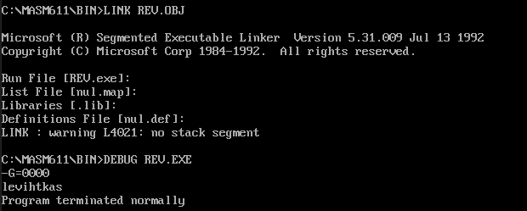

b) To check the given string is palindrome or not

assume cs:code,ds:data

data segment

block1 db 'malayalam'

msg1 db "it is palindrome $"

msg2 db "it is not plaindrome $"

block2 db ?

data ends

print macro msg

mov ah,09h

lea dx,msg

int 21h

int 3h

endm

code segment

start:

mov ax,data

mov ds,ax

lea si,block1

lea di,block2+8

mov cx,00009h

back:

cld

lodsb

std

stosb

loop back

lea si,block1

lea di,block2

mov cx,0009h

cld

repz cmpsb

jnz skip

print msg1

skip:

print msg2

code ends

end start

end

